Practical No. 4

Name:- Rizwan Siddiqui FYCS-82. Subject :- IT Tools

A]what is wikipedia ?

Wikipedia is a free content, multilingual online encyclopedia written and maintained by a community of volunteers through a model of open collaboration, using a wiki-based editing system. Individual contributors, also called editors, are known as Wikipedians. It is the largest and most-read reference work in history.

B] STEPS TO CREATE AN ACCOUNT ON WIKIPEDIA

STEP 1: Click the "Sign in/create account" link in the upper right corner on the Wikipedia website.

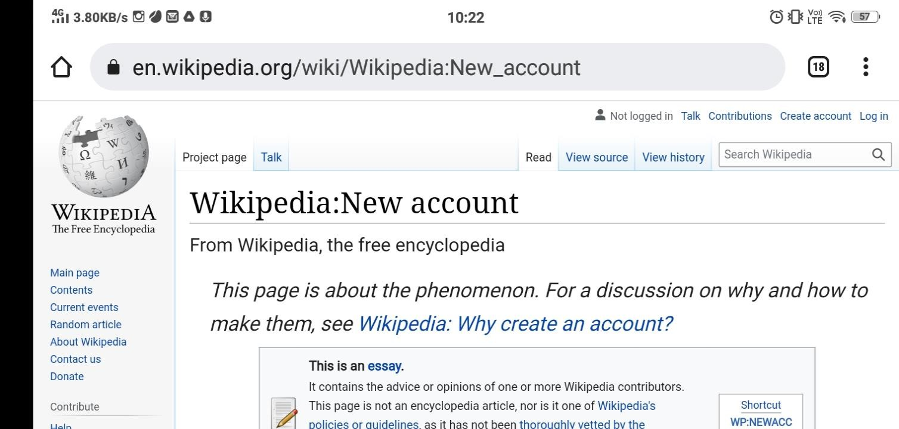

STEP 2: Click the link "Create One" above the boxes. This will take you to the account creation page

STEP 3: Enter your desired user name in the "Username:"

Enter a password in the "Password:" box. Make sure that you can remember your password, but for it to be hard for anyone else to guess.

Re-enter the same password as above in the "Confirm Password

Enter your e-mail address in the "E-mail"

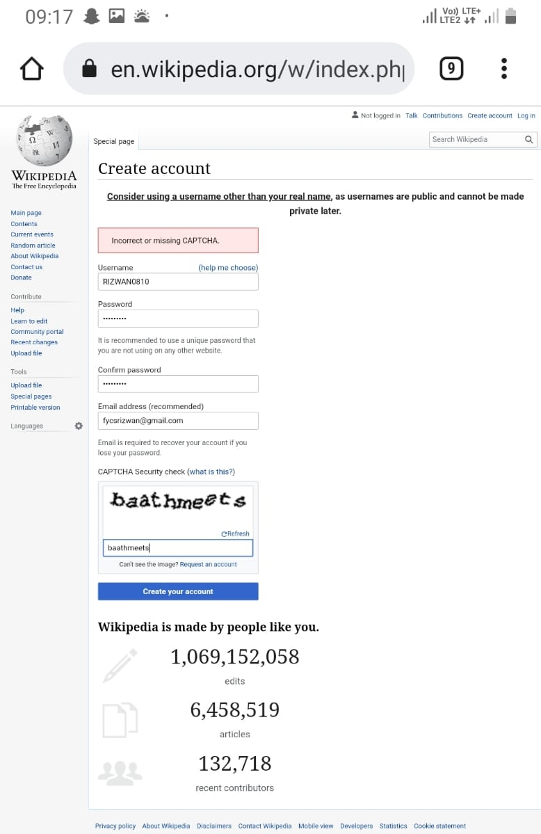

Type the captcha. Wikipedia now presents people with a simple captcha to solve to prevent against computer activated programs signing up. Type it in the box below (refresh the image if you must) and move on to the next step Click the on "Create account" button.

1. CREATING PAGE ON WIKIPEDIA

STEP1: To create page on Wikipedia click on “Sandbox”.

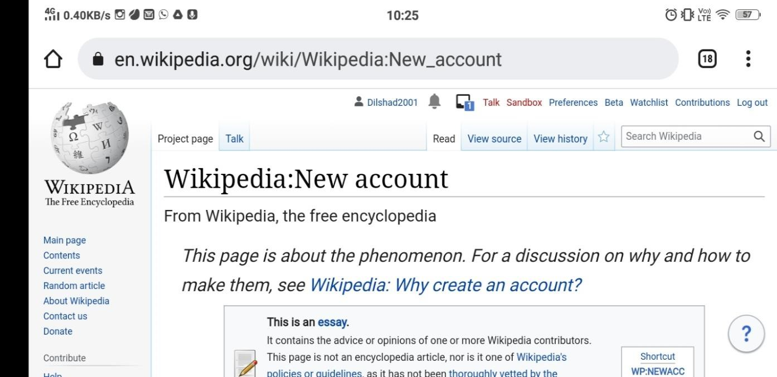

STEP 2: Type whatever you want to publish in sandbox.

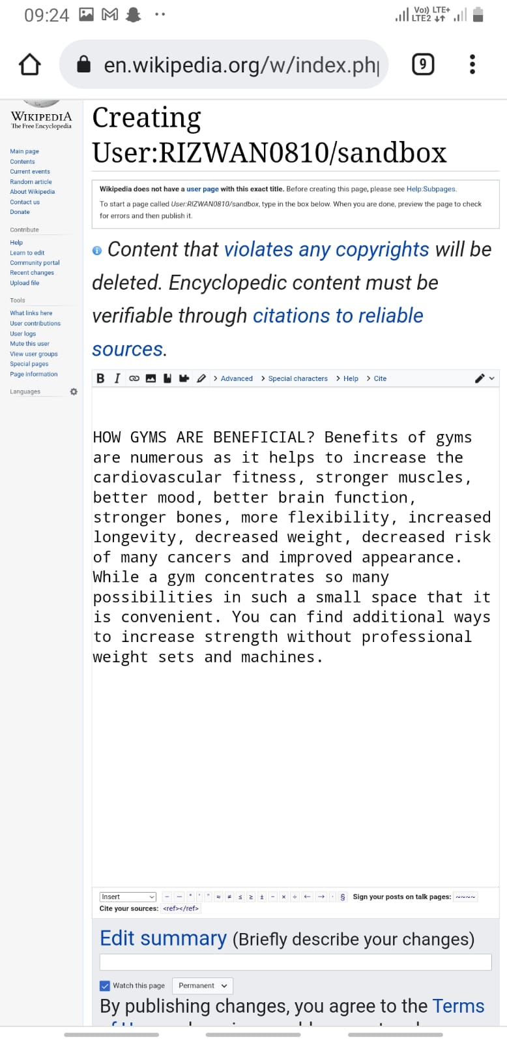

STEP 3: After typing click on “publish page”.

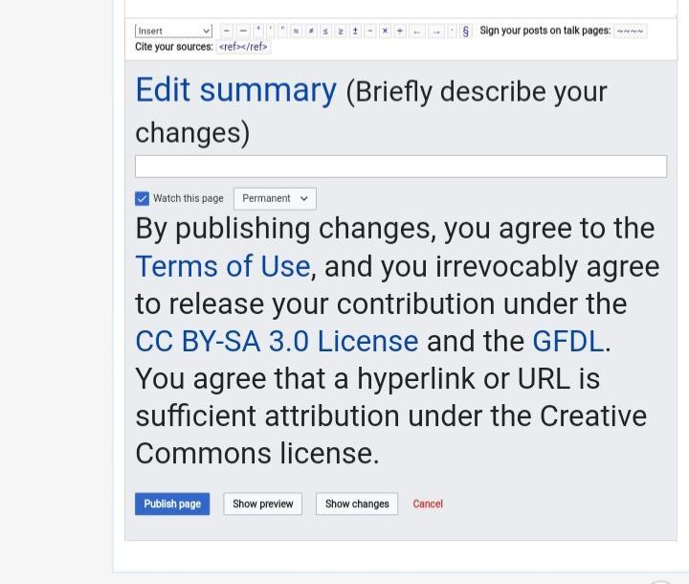

STEP 4: You page is created.

1. EDIT YOUR PAGE.

STEP 1: Click on “edit” to edit the page.

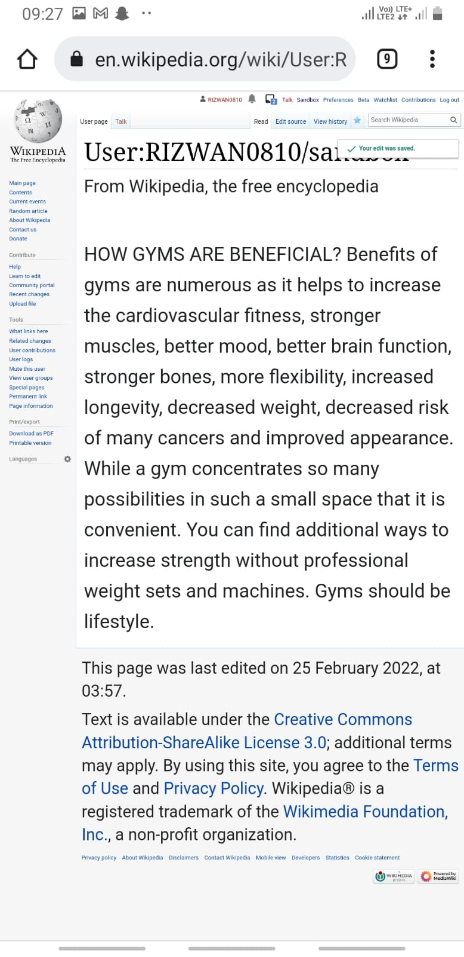

STEP2: After editing the page click on “Publish changes”

